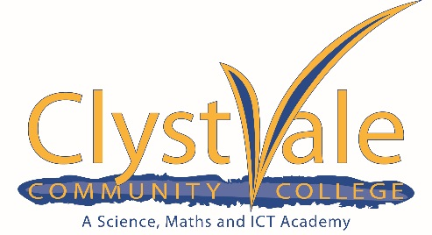

Job Description: Support Staff
Name:
Job Title: Data Team – Exams Assistant
Salary Scale: CVCC C
Hours of Work: 16 hours per week x 41 weeks hours TBA

Job Purpose
Administrative support to the Exams & Data Manager throughout the annual exam cycle. This will include attendance on exam result days during the Summer holidays. The key element of this position is flexibility to allow for attendance at college during peak exam periods outside of your normal agreed working pattern. You will also be required to deal with queries, where appropriate in the absence of the Exams & Data Manager.

Exams Administration
Support exams function throughout the year as directed by the Exams & Data Manager
This may include data entry, issuing of timetables, seating arrangements etc
Organise staff invigilation for mocks/internal exams as necessary
Organise room changes for exams as necessary
Help with organisation of and attendance at GCSE awards evening
Administration of onscreen tests
Check & collate, issue exam certificates
Assist with results day administration

ADDITIONAL RESPONSIBILITIES
You may also be required to undertake any administrative task as directed by the College Manager or any additional member of SLT. At times this may sit within another Administrators role. This is to ensure the smooth running of the College at all times.

TO WHOM RESPONSIBLE
Exams & Data Manager

This job description is not a comprehensive definition of the post. Opportunity to discuss your individual responsibilities will be available during your appraisal interview with your line manager, which will normally take place in the Summer term.

Person Specification
Role Requirements: | Essential | Desirable | How Assessed
Qualifications:
5 GCSEs at C or above including a minimum of GCSE grade C in English and Maths. | √ |  | Application Form
Experience:
Working in a school environment with young people. |  | √ | Application Form; Interview; References
Analysing information systematically and working with great attention to detail. | √ |  | Application Form; Interview; References
Working within a busy environment, meeting tight and demanding deadlines. | √ |  | Application Form; Interview; References
General administration and familiarity with SIMS |  | √ | Application Form; Interview; References
Using a range of ICT packages and databases | √ |  | Application Form; Interview; References
Personal and Professional Skills & Attributes
Good interpersonal skills including;  - Ability to build rapport quickly  - Ability to be assertive when required  - Professional & approachable style | √ |  | Application Form; Interview; References
Excellent planning and organisational skills. Able to prioritise and organise own day-today work in accordance with deadlines and agreed objectives. Flexible and adaptable in approach. | √ |  | Application Form; Interview; References
Strong communication skills, able to;  - Convey information confidently, appropriately and effectively.  - deal with internal and external contacts to high professional standards.  - build positive professional relationships with stakeholders and examining boards | √ |  | Application Form; Interview; References
Numeracy, literacy and ICT skills at a level appropriate to the role.  - Highly competent Microsoft office (Outlook, Word & Excel) user. | √ |  | Application Form; Interview; References
Able to manage confidential information appropriately and with discretion including dealing with sensitive and personal issues in complete confidence. | √ |  | Application Form; Interview; References
- Willingness to participate in ongoing training & development | √ |  | Application Form; Interview; References
Able to work effectively as a member of a team | √ |  | Application Form; Interview; References
Understanding of safeguarding issues and able to promote the welfare of children and young people. | √ |  | Interview

