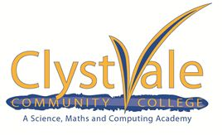

Request to Sit GCSE Exams in the Autumn 2020 series

Following the Ofqual consultation decision, you have the opportunity to sit exams in the subjects you were entered for in Summer 2020, should you wish to do so. Most GSCE exams will take place between 2 and 23 November. Any exams you intend to sit will be held here at Clyst Vale Community College. Please fill out the form fully and clearly, indicating which subjects you would like to be entered for, and return it to R Dominy at dominyr@clystvale.org by Friday 11th September. Due to entry deadlines late forms will not be accepted. Your candidate number and subject code can be found on your results slip.

The Autumn exams will not include any form of coursework and the grades will be entirely based on the exams. In order to achieve a full grade in a subject, all the relevant exams must be taken.

Please note that there are no BTEC or Cambridge National exams in the Autumn series.

Candidate name: |  | Candidate number:
Email address:

Exam board (e.g. AQA, Edexcel, OCR) | Subject | Subject Code  (available on your results slip) | Tier (H or F)

If you are returning to CVCC in September for Post16, please tick here ☐

Candidate request

Please enter me for the above subjects in the Autumn series. I understand that if I withdraw after the deadline or do not turn up for an exam I am entered for I will be invoiced for the cost of the exam.

Candidate signature: Date:

Parent/Guardian consent

Print name:

Signature: Date:

