CLYST VALE COMMUNITY COLLEGE

EXAM BOOKLET



NAME:
Centre No: 54203
College Telephone No: 01392 461407

CONTENTS

 | Page
INTRODUCTION | 2
Warning to Candidates | 3
JCQ Information for candidates | 4-7
BEFORE THE EXAMINATIONS | 8
Statements of Entry | 8
Candidate Name | 8
Candidate Number | 8
Timetables | 8
Clashes | 8
Uniform | 8
Contact Numbers | 8
Equipment | 9
Exam Preparation Time/Study Leave | 9
Study Facilities | 9
Registration during the exam period | 9
Careers Advice | 9
DURING THE EXAMINATIONS | 10
Examination Regulations | 10
Attendance at Exams | 10
What to Bring to Examinations | 10
Examination Desks | 11
Procedures for all Exams | 11
Invigilators | 12
Lateness | 12
Non-Attendance | 12
AFTER THE EXAMINATIONS | 13
Special Consideration | 13
Returning your college books etc | 13
Year 11 Prom | 13
Return of Coursework | 13
Results | 13
Enquiry & Appeals Process | 14
Non-Examined Assessment/Coursework Appeals | 14
Exam Result Appeals | 14
Certificates | 14
Frequently Asked Questions | 15-17
Checklist | 18
Enquiry & Appeals Form | 20
“All talk and no action doesn’t get you anywhere.”
Aesop’s Fable

INTRODUCTION

This booklet contains information to help you before, during and after your examinations.

The examination boards set out strict rules for the conduct of all examinations and Clyst Vale Community College must follow them exactly. Every year we, like all exam centres, are subject to visits by examinations’ inspectors, who have the power to remove our examination centre status if we do not follow the rules. Please read the JCQ Information for Candidates on pages 4-7, so that you know what is expected of you.

At the back of the booklet are answers to some of the most frequently asked questions. We are here to help you, so if there is anything you or your parents do not understand please ask.

The College has one centre number for all GCE & GCSE Exams:
54203

You must use this number for all your examinations.

The Exams Officer is:
Mrs Dominy
01392 463920
dominyr@clystvale.org

The college telephone number is:

01392 461407

Exams email address for queries and messages during the exam periods only eg for absences/emergencies on the day of an exam:

exams@clystvale.org

Good luck in all your exams.

“I am a great believer in luck, and I find the harder I work the more I have of it.”
Stephen Leacock

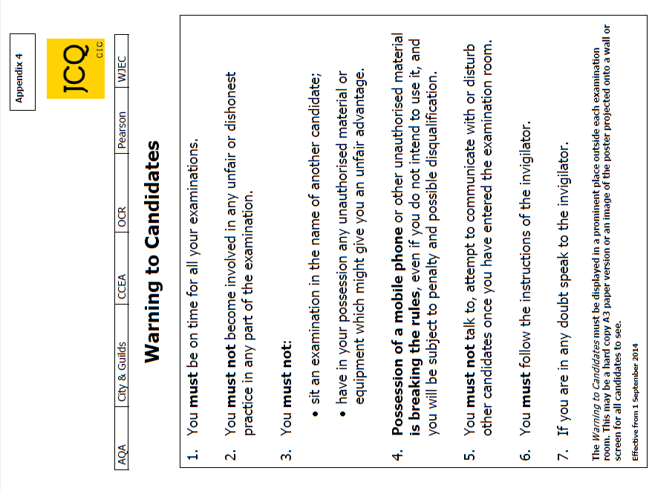

JCQ Information for Candidates
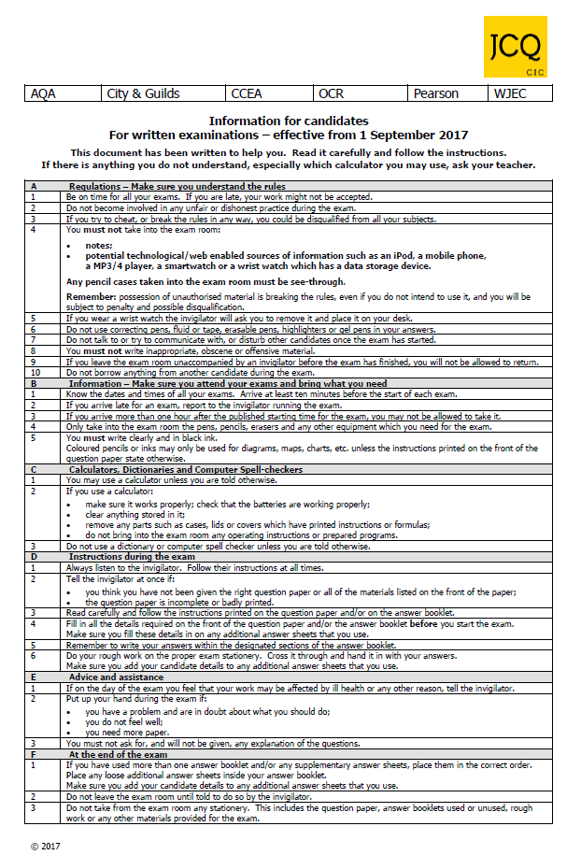

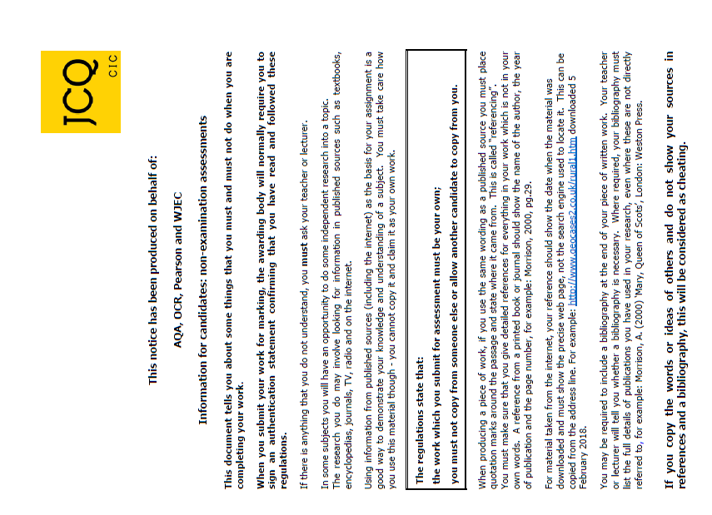
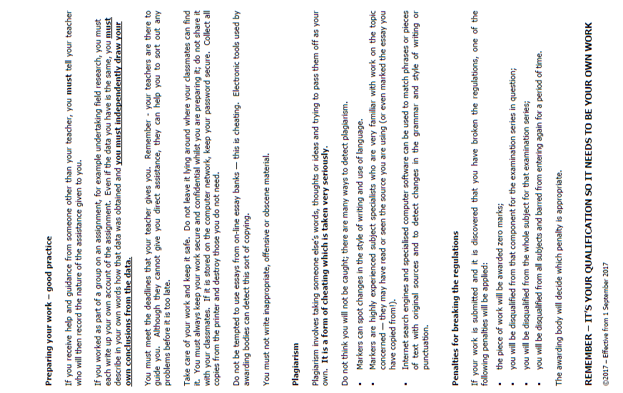
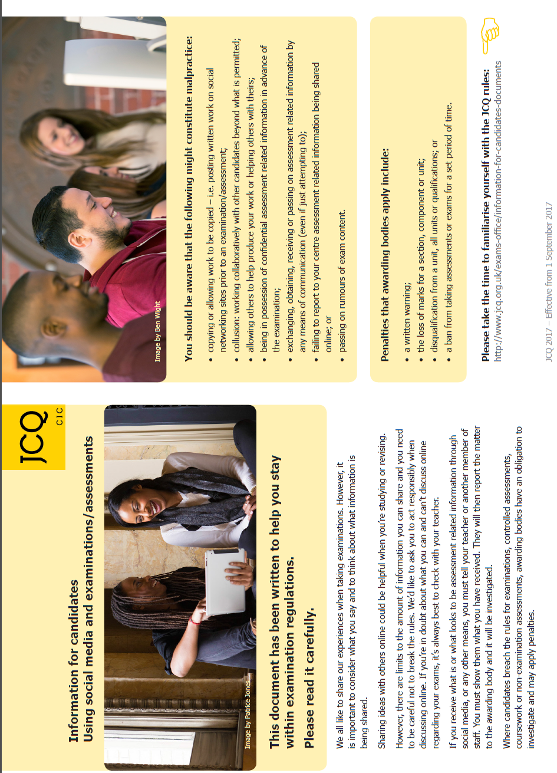

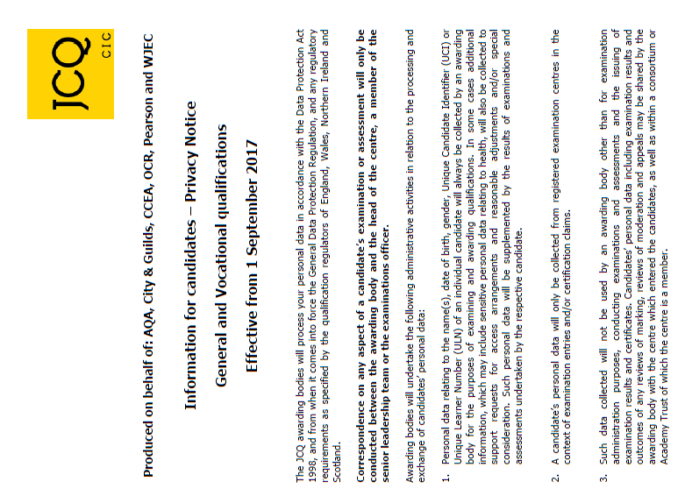
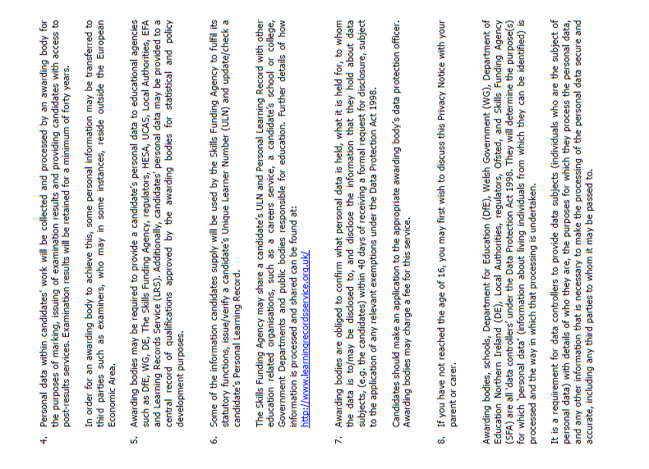

BEFORE THE EXAMINATIONS

STATEMENTS OF ENTRY

In February you will receive a Statement of Entry. It is vital that you check this carefully. The statement shows your name, date of birth, exam number and details of the exams for which you have been entered. Please see Mrs Dominy if there are any mistakes or queries. Queries relating to tiers (Foundation/Higher) should be referred to subject teachers).

CANDIDATE NAME

Candidates are entered under the format of (legal) first name + middle initial + (legal) surname, e.g. Adam J. Smith. You MUST write your legal name on your exam papers, not your preferred name.

CANDIDATE NUMBER

Each candidate has a four figure exam number. This is the number you enter on all your exam papers. Please learn it. If for any reason you do forget it, you will find it on your identity card on your exam desk during formal written exams.

TIMETABLES

Towards the end of the Spring term you will receive your final individual timetable. This will show you the date, time, venue and seat number for all your examinations. Please check it carefully and if something is wrong please see Mrs Dominy in the Exams Office.

It is your responsibility to attend the correct examinations at the correct times on the correct days.

CLASHES

There are always a few exam clashes and if you are affected you will receive separate details regarding the arrangements for these. It is very important that you follow these carefully – see Mrs Dominy if you are uncertain as to what is expected of you.

UNIFORM

You must wear college uniform to all examinations – you will not be admitted to the examination room if you are out of uniform. Trainers, unauthorised jewellery,
t-shirts or outdoor clothing are not permitted in the examination rooms. Remember that the temperature in the exam room can fluctuate enormously during May/June. So bring a jumper with you as you can always take it off if you get too warm.

CONTACT NUMBERS

Please check that the college has at least one up-to-date contact number for you and your home.

EQUIPMENT

Make sure that you have all the correct equipment before your examinations. Check the information on the following pages.

All answers in all examinations must be made using a BLACK ink pen or biro.

EXAM PREPARATIONTIME/STUDY LEAVE

Lessons will run as normal until the end of Friday 25th May. Students should continue to be in college throughout the day, either in an exam or in their timetabled lessons. Where examinations for a subject have all been taken you must bring suitable revision to do during the lesson.
Study leave will thus start on Monday 4th June. However, staff will be running revision sessions during normal timetabled slots up until the last exam in that subject has been taken.
Check your timetable very carefully so that you do not miss an examination.

STUDY FACILITIES

These will be provided in school throughout the day during study leave. If you remain on site during the day and do not have an exam or a revision session, you must go to the allocated study room and not wander around the site. It is your responsibility to bring revision work, or to access the appropriate revision websites. Students who do not wish to work in the study room must sign out and go home until the time of their next exam. Further details will be communicated to students in a separate document.

REGISTRATION DURING THE EXAM PERIOD

Whenever you are in College for a morning or afternoon session (or part thereof) you must be marked present in the register. During the exam period this becomes a complicated procedure because not everyone arrives at the same time.

You are therefore required to mark the register yourself. This is very important for Health & Safety reasons. The register will be outside the Giraffe House, under the stairs. You will need to mark in the time you arrive and the time you leave.

CAREERS ADVICE

If you need post-results advice various members of staff will be available to talk to you on Results Day.
You can also contact Careers South West for advice:
37/39 Queen St, Exeter. EX4 3SR Telephone: 01392 203603. Email: exeter@careerssw.org.
Opening times: Mon – Fri 10 am – 4 pm. Their Adviser Online service is available from midday to 6 pm, Monday to Friday.

DURING THE EXAMINATIONS

EXAMINATION REGULATIONS

The Examining Boards issue Warning to Candidates and Information to Candidates sheets which are printed at the front of this booklet. Please read them carefully and note that the breaking of any of the regulations could lead to disqualification from all subjects. The college MUST report any breach of regulations to the Examining Board.

ATTENDANCE AT EXAMINATIONS

It is the candidate’s responsibility to arrive FIFTEEN MINUTES before the start of the exam in full college uniform and with the proper equipment.

WHAT TO BRING TO EXAMINATIONS

All students are required to bring the following equipment to each examination in a colourless see-through pencil case (the zip may be coloured by not the main body of the pencil case) or see-through plastic bag. No other pencil cases are allowed.
- At least two BLACK ink pens or Biros. (Not gel pens, erasable pens or highlighters.)
- At least two HB pencils (e,g, for graphs, but make sure the lines are dark enough to be picked up by a scanner).
- Ruler.
- Rubber.
- Appropriate instruments e.g. protractors, compasses, crayons etc when necessary.
- Calculator (see below).

You may bring water in a clear plastic bottle. Bottles must have labels removed.

Unauthorised Material. You may not bring unauthorised materials into the examination room. When taking exams in the hall, bags, coats, calculator cases/instruction leaflets and non see-through pencil cases must be left in the changing rooms. These are locked during the exam. If your exam is in a small room, bags and coast should be left at the back of the room (but don’t forget to make sure your mobile phone has been switched off).

Calculators. You may use one unless you are told that you must not do so. If you do use a calculator it must be silent, cordless and non-programmable. You may not share a calculator with anyone else. You are not allowed to take instruction booklets for your calculator into the exam room. No allowance can be made by the examiners for the breakdown of calculators and you are advised to bring spare batteries or a spare calculator with you. In calculations you are advised to show all steps in your working, giving your answer at each stage – marks are often given for working out and, even if you get the final answer wrong, you may still receive some marks if part of what you have done is correct.

Spell Checkers. You must not use a dictionary or computer spell checker unless you are told you may do so by the invigilator of that examination.

Watches. Please make sure that any watch alarms are turned off. Apple/Smart watches will not be permitted in the Exam Room. Watches must be taken off and placed on the desk during the exam.

EXAMINATION DESKS

Please do not write on examination desks. This is regarded as vandalism and you will be expected to pay for any damage or replacement.

PROCEDURES FOR ALL EXAMINATIONS

Your individual timetables will tell you the room and desk numbers where you will sit. Check your timetable in advance of the exam so that you know where you need to go for each exam. Seating lists will be placed outside the Sports Hall each day for you to check if you need to.

You must not talk or make any contact with another candidate whilst in the examination room - if you do, your paper will be cancelled. Any attempt to cheat will be reported to the Examination Board and may lead to disqualification.

If you drop anything on the floor, do not attempt to pick it up. Raise your hand and ask an invigilator to retrieve it for you.

Do not draw graffiti or write offensive comments on examination papers – if you do the Examination Board may refuse to accept your paper.

Read all instructions carefully.

You will not be allowed to leave the examination room early. If you have finished the paper use any remaining time to check your answers and make sure you have completed your details correctly.

You must hand in all work at the end of the exam. Put a neat line through any rough work you do not want marked.

All exam papers will be collected before you leave the room. No exam materials must be taken from the room. Remember you are still under exam conditions until you have left the room. Once your exam is over and everything has been collected in you will be dismissed from the room row by row. Please leave in silence in an orderly fashion so as not to disturb any candidates who may still be working.

If the fire alarm sounds during an examination the examination invigilators will tell you what to do. Don’t panic! If you have to evacuate the room you will be asked to leave in silence and in the order in which you are sitting. You will be escorted to a designated assembly point on the tennis courts. Leave everything on your desk. You must not attempt to communicate with anyone else during the evacuation. When you return to the exam room do not start writing until the invigilator tells you to. You will be allowed the full working time for the examination and a report will be sent to the awarding body detailing the incident.

INVIGILATORS

The college employs external invigilators to conduct the examinations. Students are expected to behave in a respectful manner towards all invigilators and follow their instructions at all times.

Invigilators are in the examination rooms to supervise the conduct of the examination. They will distribute and collect the examination papers, tell candidates when to start and finish the examination, hand out extra writing paper if required and deal with any problems that occur during the examination, for example if a candidate is feeling ill.

Please note that invigilators cannot discuss the examination paper with you or read/explain the questions.

Pupils who are disruptive or behave in an unacceptable manner will be removed from the examination room and dealt with appropriately under college rules. Their conduct may be reported to the Examination Board which could result in disqualification.

LATENESS

If you arrive after the examination has started see Mrs Dominy. Exam boards do not usually accept work done by candidates who arrive more than an hour late; less for shorter exams. Please phone the college on 01392 461407 as soon as possible if you are having problems and think you will arrive late. If possible, please also email exams@clystvale.org as this will be received quickly by the Exams Officer.

Make plans to get to college early and take into account problems which may occur with transport etc.

NON-ATTENDANCE

If you fail to turn up for an examination without good reason you will be charged the entry fee. Please note that misreading the timetable will not be accepted as a satisfactory explanation of absence. If you are ill you will need a letter from a responsible adult and/or a doctor’s note. Please see Mrs Dominy regarding this so that we may appeal to the Examination Board on your behalf. You may not sit the examinations at any times other than those shown on the timetable. If you miss more than 75% of the whole qualification (this includes controlled assessments) you will not receive an overall grade, even if you are ill.

If you are unable to attend college through illness on a day when you have an examination it is essential that an adult from home contacts college on 01392 461407 before 8.30a.m. to explain the reason for your absence. If you can, please email exams@clystvale.org so that the Exams Officer knows as soon as possible.


It is your responsibility to be on time, on the right day and properly prepared for your examinations.

AFTER THE EXAMINATIONS

SPECIAL CONSIDERATION

There are many things which can affect your performance during examinations such as recent illness, bereavement, family trauma, and some accidents. If you are badly affected by any of these the college can apply for special consideration from the examination boards. However, you must be able to support your appeal by a letter from someone in authority. Speak to Mrs Dominy for advice.


IMPORTANT – RETURNING BOOKS!

Textbooks must be returned on, or before, the day of your last exam in each subject. Return them directly to the subject teacher. If there are any books outstanding or monies owing there may be a delay in receiving your exams results until clearance is finalised.


Year 11 Prom

This will take place on Friday 29th June 2018.

RETURN OF COURSEWORK

It may be possible for you to have your coursework back from some subjects after the results are published. Please speak to your individual subject teachers for further details.

RESULTS

The college will be open as follows for the collection of exam results:

GCSE results Thursday 23rd August 9.00 a.m. to 10.30 a.m

Any results not collected will be posted to you provided you have completed the clearance procedure. Please make sure that you let Mrs Dominy have details if you need your results sent to a different address (in UK only). We do not email results to students or parents, nor do we ever give out results over the phone.

If you need someone else to collect your results they must have a letter of authorisation from you, even if this is a parent.

Enquiry and Appeals Process

Non-Examined Assessment (NEA)/Coursework Appeals

Clyst Vale Community College is committed to ensuring that whenever its staff mark candidates’ work this is done fairly, consistently and in accordance with the awarding body’s specification. On being informed of their centre assessed marks, if a candidate believes that the correct procedures were not followed in relation to the marking of his/her work, or that the assessor has not properly applied the mark scheme to his/her marking, then he/she may make use of the NEA appeals procedure to consider whether to request a review of the centre’s marking. The policy and appeals procedure can be found on the school website under ‘Exams & Revision’.

Exam Results Appeals

If, when you receive your results, you find some of your grades are unexpectedly low, you can ask for a clerical check or a review of marking. You can also request to see the marked paper. Exam boards do not accept requests directly from students so you have to do this via the college. Exam boards charge fees for this (approx. £40 per paper). Remember that marks can go down as well as up!

If you wish to make an appeal you must complete an appeal form (see page 20 - further copies will be available on Results Day and will include fees information) and hand them into the college by Friday 7th September.

CERTIFICATES

Certificates are usually issued by the Exam Boards around the end of October. These are presented to students at the GCSE Presentation Evening in November. If you do not attend the evening, you may collect them in person from the reception after this date or write a letter of permission for someone else to collect them for you. Clyst Vale Community College is only obliged to keep certificates for a period of one year after issue but in practice keeps them for 3 years. If candidates do not collect their certificates within this time (or if they lose their certificates) they can only be replaced by direct application to the appropriate exam boards. This will require proof of identity and a substantial fee per examination board. You are therefore urged to collect your certificates promptly and keep them safely.

The GCSE Presentation Evening will take place in November and invitations will be issued closer to the date. We hope that as many students as possible will be able to make the evening.



FREQUENTLY ASKED QUESTIONS

Q. What do I do if there’s a clash on my timetable?
- The college will re-schedule papers internally (on the same day) where there is a clash of subjects. Candidates will normally sit one paper then have a break during which they will be supervised and must not have any communication with other candidates. They will then sit the second subject paper. Correct times should be on your individual candidate timetable. It may be necessary for you to bring a packed lunch if you have exams in the morning and afternoon as you will have to remain in isolation until both examinations are completed. If in doubt ask Mrs Dominy.

Q. What do I do if I think I have the wrong paper?
- Invigilators will ask you to check before the exam starts. If you think something is wrong put your hand up and tell the invigilator.

Q. What do I do if I forget my Candidate Number?
- Candidate Numbers are printed on your Exam Identity Card which you will find on your exam desk.

Q. What do I do if I forget the college Centre Number?
- The Centre Number is 54203. It will be clearly displayed in the examination rooms and is printed on your Exam Identity Card.

Q. What do I do if I have an accident or I am ill before the exam?
- Inform the college as soon as you can so that we can help and advise you. In the case of an accident that means you are unable to write it may be possible to provide you with a scribe to write your answers, but we will need as much prior notice as possible.
You may need to obtain medical evidence (from your GP or hospital) if you wish the college to make an appeal for Special Consideration on your behalf (see below).

Q. What is an Appeal for Special Consideration?
- Special Consideration is an adjustment to the marks of a candidate. The allowance for Special Consideration is from 0% (consideration given but addition of marks considered inappropriate) to 5% (reserved for exceptional cases). You should be aware that any adjustment is likely to be small and no feedback is ever provided. Candidates will only be eligible for Special Consideration if they have been fully prepared and covered the whole course but performance in the examination is affected by adverse circumstances beyond their control. Examples of such circumstances may be illness, accident or injury, bereavement and domestic crisis. The Examination Officer must be informed immediately, so that the necessary paperwork can be completed (within 7 days of the last exam session for each subject) and the candidate will be required to provide evidence to support such an application.

Q. What do I do if I feel ill during the exam?
- Put your hand up and an invigilator will assist you. You should also inform an invigilator if you feel ill before or during an exam and you feel that this may have affected your performance.

Q. If I’m late can I still sit the examination?
- Provided you are not more than 1 hour late (unless the paper is less than one hour long!), it may still be possible for you to sit the examination. You should get to college as quickly as possible and report to Reception. A member of staff will escort you to the exam room. You must not enter an examination room without permission after an examination has begun.

You should also be aware that if you start the exam more than 60 minutes after the published starting time, the college must inform the exam board and it is possible that the board may decide not to accept your work. Please ensure that you allow enough time to get to college so that if you are delayed (e.g. through transport problems) you will still arrive on time.

Q. If I miss the examination can I take it on another day?
- No. Timetables are regulated by the exam boards and you must attend at the given date and time.

Q. Do I have to wear college uniform?
- Yes.

Q. How do I know how long the exam is?
- The length of the examination is shown in minutes on your individual timetable under the heading ‘duration’ and also on the front of the exam paper. Invigilators will tell you when to start and finish the exam. They will display the finish time of the exam on a screen at the front of the exam room. There will be a clock in the exam room.

Q. Which equipment should I bring for my exams?
- For most exams you should bring at least 2 pens (black ink only).
- For some exams you will need a calculator (e.g. Maths/Science), a 30cm ruler (marked with cm and mm), pencil sharpener and rubber, compasses, protractor, coloured pencil crayons (not gel pens).
- You are responsible for providing your own equipment for examinations. You must not attempt to borrow equipment from another candidate during the examination.

Q. Which items are not allowed into the examination room?
- Only material that is listed on question papers is permitted in the examination room and students who are found to have any material with them that is not allowed will be reported to the examination board. In such circumstances, a student would normally be disqualified from the paper or the subject concerned.
- Bags and coats and any other items not permitted under examination regulations must be left in the changing rooms. Do not bring any valuables into college with you when you attend for an examination.
- Only water in a see-through plastic bottle is allowed in the exam room. Any labels must have been removed.
- Mobile telephones must not be brought into the exam room even if they are turned off.

Q. Why can’t I bring my mobile telephone into the exam room?
- Being in possession of a mobile phone or any other electronic communication device (e.g. i-pods, smart watches, headphones) is regarded as cheating and is subject to severe penalties from the awarding bodies:

The minimum penalties are as follows:
Device found on you and turned ON - disqualification for the entire subject award.
Device found on you and turned OFF – disqualification from the specific paper you are sitting at the time.
Phone rings during the exam wherever it is in the room - you may be disqualified from all subjects with that exam board.

Q. Can I leave the exam early?
- No.

Q. What do I do if the fire alarm goes off?
- The examination invigilators will tell you what to do. If you have to evacuate the room leave everything on your desk and leave the room in silence. You must not attempt to communicate with any other candidates during the evacuation.

Q. Can I go to the toilet during the exam?
- If it is absolutely necessary. You will be escorted by an invigilator and will not be allowed any extra time unless you are ill.

Q. If I have more than one exam on a day can I get lunch at college?
- Pupils who have examinations in both morning and afternoon sessions may obtain lunch from the canteen in the usual way, or bring a packed lunch.

Q. Why do I need to check the details on the Statement of Entry?
- The details on your Statement of Entry will be used when certificates are printed. If the name or date of birth on your certificates does not match your birth certificate it could cause you problems when you are asked to show your certificates to a potential employer or college/university at some time in the future. You should also check that the subjects and tiers of entry you are entered for are correct and that no subjects are missing.

CHECK LIST

- Read this booklet carefully.

- Discuss this booklet with your parents/guardians.

- Read and use the Exam Revision Guide to help prepare you for your exams.

- Check your Statement of Entry and Individual Timetable sheets for errors.

- Sort out your calculator, batteries, pens etc.

- Hand back your text books and library books.

- Make sure that the College Office has your correct home address and telephone number on file.

- Turn up on time, in the correct college uniform and be well prepared for your exams.

- Tell your form tutor, your Head of School or Mrs Dominy if you have a problem. Ask if you have a question.

- Make a note of Results Day or make arrangements for someone else to collect your results and provide them with a letter of permission.

Give all your examinations 100% effort and good luck!

Mrs R Dominy Mrs J Turner
Examinations Officer Senior Invigilator

Enquiry and Appeals Form

Information for candidates

If you achieve a surprising result in an exam you may be able to make an appeal to the Exam Board. This must be done via your college and can take several formats;
- You can ask for a clerical check to be made (ie a check that the marks were added up correctly).
- You can ask for the paper to be re-marked.
- You can ask for a copy of the exam paper. (Once returned the paper cannot be re-marked).
If your mark changes, up or down, the new mark is the final mark and supersedes all previous marks. You cannot appeal against a re-mark or ask for the previous mark to be reinstated.
If you would like to request an appeal, please complete this form and enclose the appropriate fee. If the overall grade is amended the fee will not be charged.
In order to initiate the appeals process the college MUST have the student’s consent. The consent form must therefore also be completed and sent to the college before the appeals deadline. Please note that the exam boards can take over 30 days to inform us of enquiry results. Once we know the outcome we will notify you.

Candidate Consent Form Centre: Clyst Vale Community College Centre No: 54203

Candidate name: ……………………………………….…………… Candidate No: …………….

Candidate email address: …………………………………………………………………………..

Level (please tick as appropriate): GCSE ….…... Alevel ….…… BTEC ……... Other …………....

Exam board (please tick as appropriate) : AQA ……. .OCR …….. Edexcel ….…. Other ……………….

Subject Title: ……………………………………… Paper/Unit Code: ……………………………

Service Requested (see PRS Information sheet*): …………………………………….……………………

Fee payable (see PRS Information sheet*): …………...… (Please make cheques payable to Clyst Vale Community College)

I give my consent to the Exams Officer to make an enquiry about the result in the above exam paper on my behalf. In giving consent I understand that the final subject grade awarded to me may be lower than, higher than or the same as the grade which was originally awarded to me.

Signed: ………………………………………………………. Date: …………………………

*Post-results Services Information Sheet will be available on Results Day when the Exam Boards have published their deadline and fees information for Summer 2018 exams.

