Autumn Term Discovery maths 7C 2019-20
4th Sep
Entry tests
9th Sep

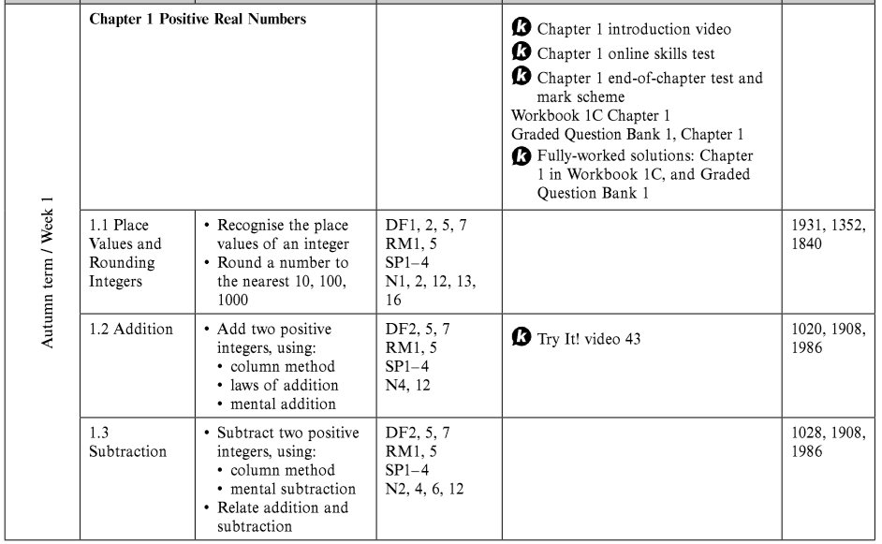

16th Sep

23rd Sep

30th Sep
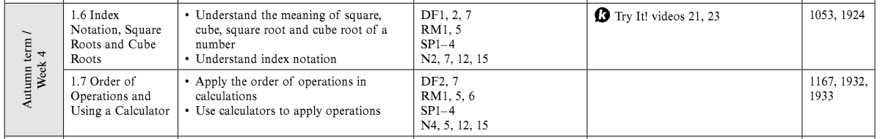

7th Oct

14th Oct
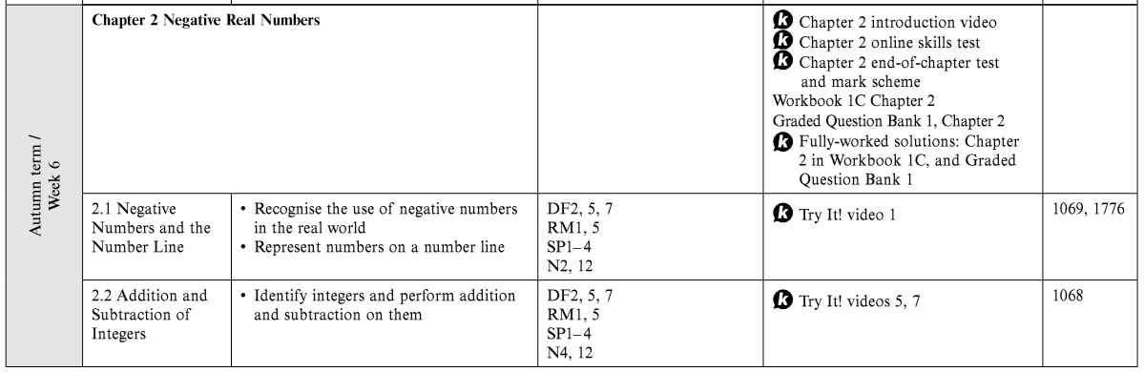

21st Oct – Half term

28th Oct
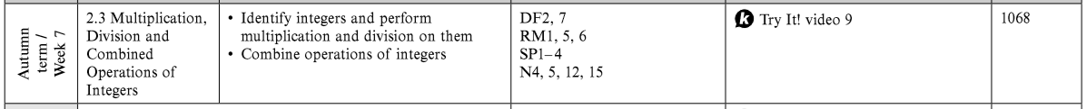

4th Nov
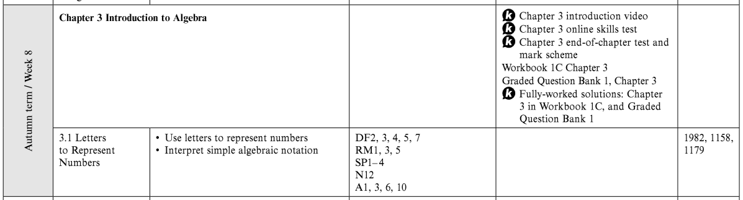

11th Nov
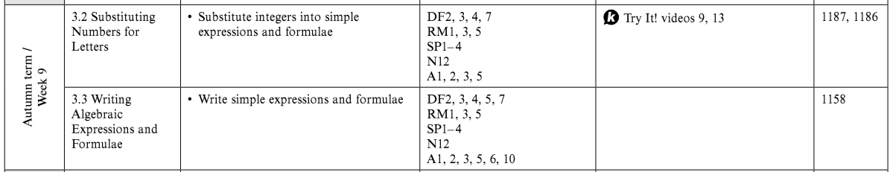

18th Nov
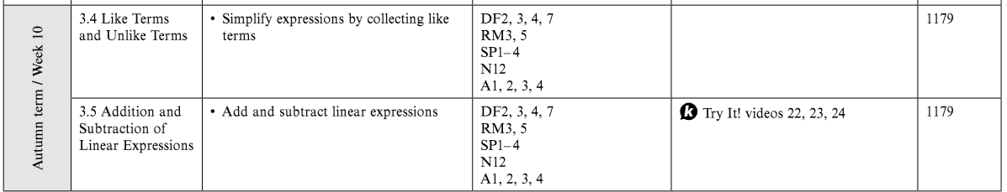

25th Nov
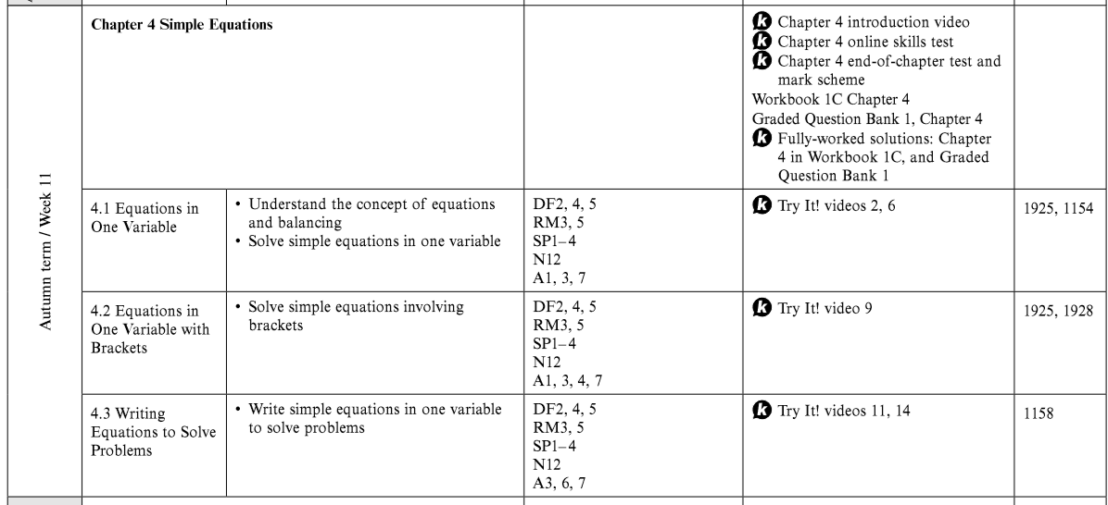

2nd Dec
