AutumnTerm Discovery maths 7A 2019-20
4th Sep
Entry tests
9th Sep
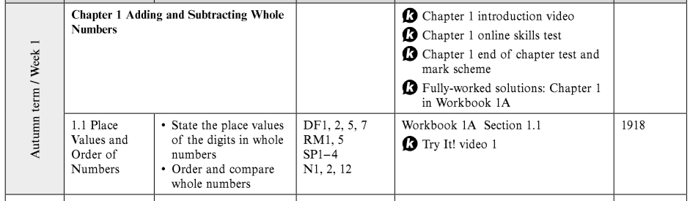

16th Sep
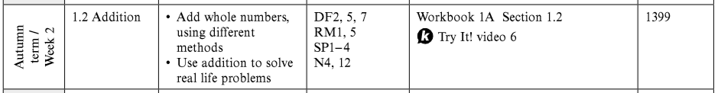

23rd Sep
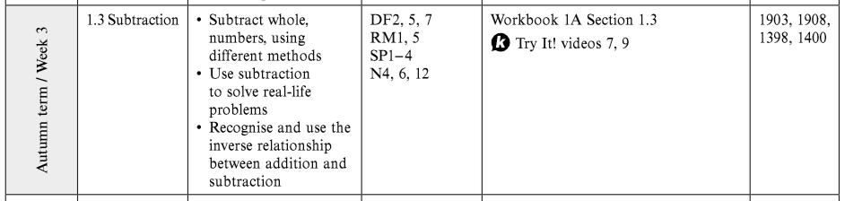

30th Sep
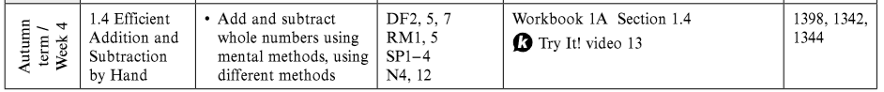

7th Oct
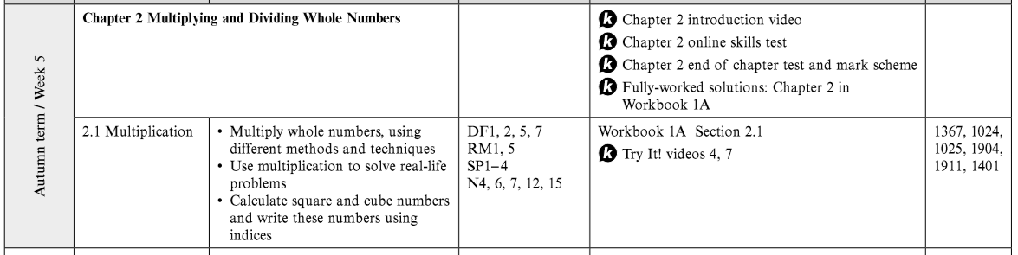

14th Oct
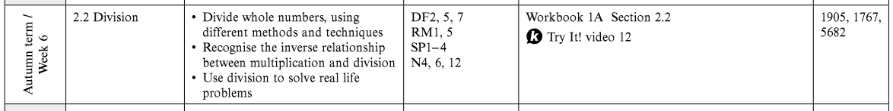

21st Oct – Half term

28th Oct

4th Nov
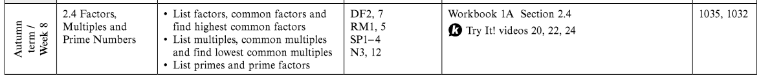

11th Nov
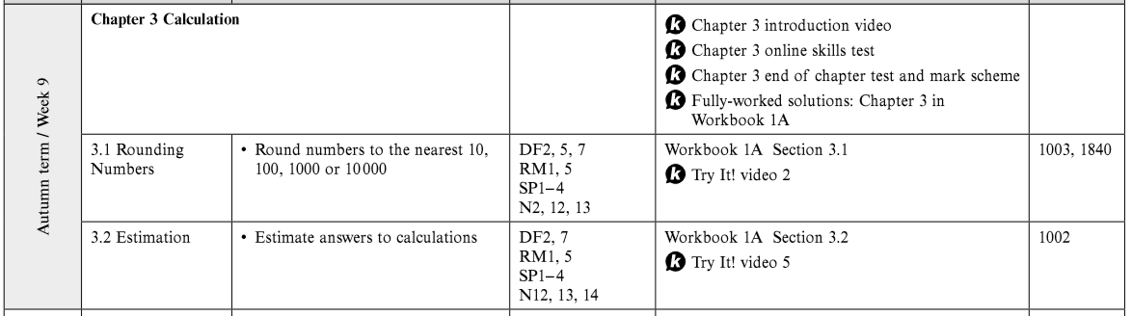

18th Nov
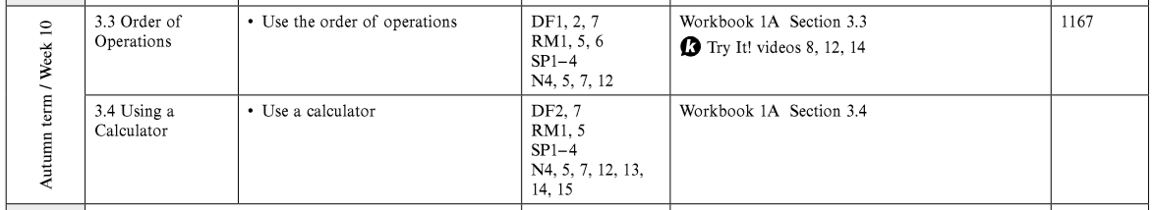

25th Nov
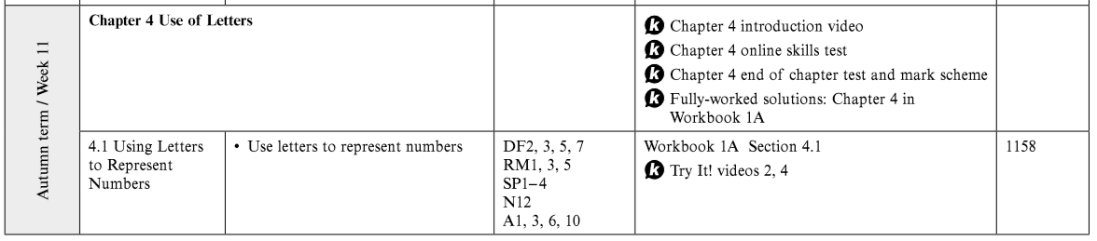

2nd Dec
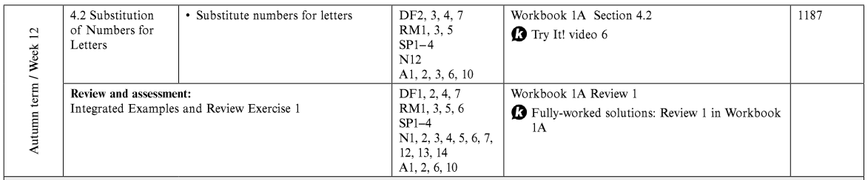

9th Dec
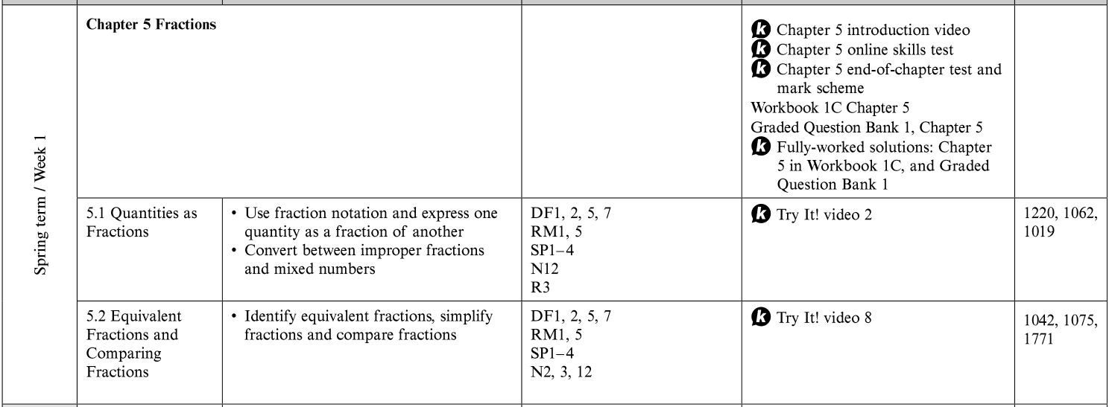
16th Dec

