AUTUMN TERM DISCOVERY MATHS 2C YEAR 8
MON B 9TH SEPT
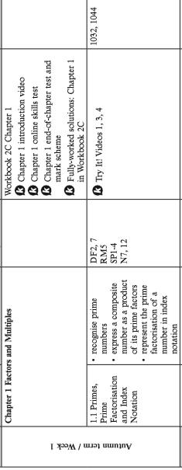
MON A | 16 SEPT
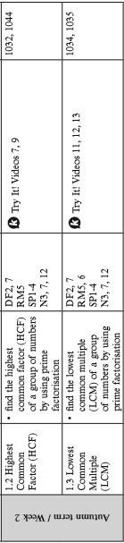

MON B 23 SEPT
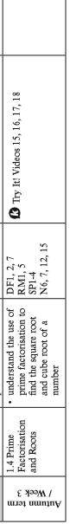
MON A 30 SEPT
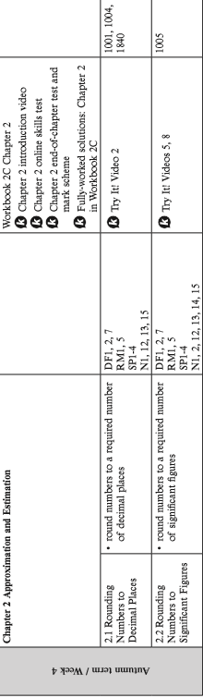

MON B 7 OCT
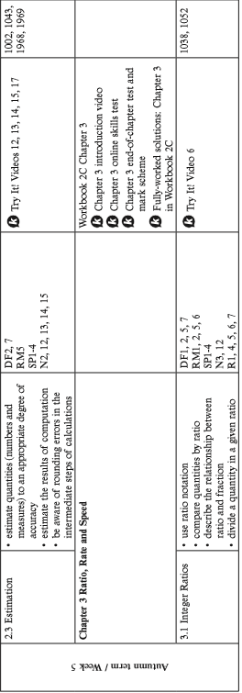

MON A 14 OCT

HALF TERM SAT 19 OCT – SUN 27 OCT
MON B 28 OCT
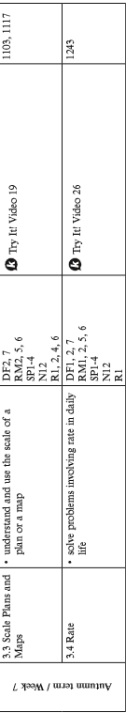

MON A 4 NOV
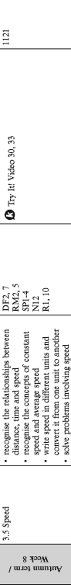

MON B 11 NOV
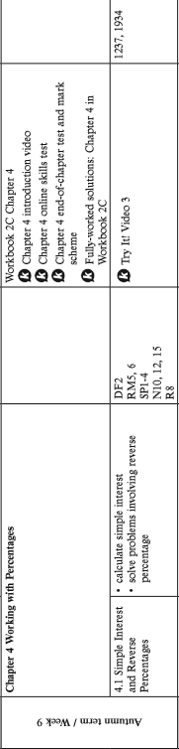

MON A 18 NOV
MON B 25 NOV
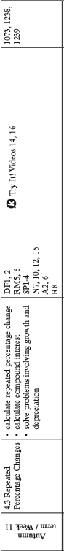
MON A 2 DEC
MON B 9 DEC COMPLETE ASSESSMENTS AND GO THROUGH THEM
ASSESSMENT 1: EXTENSION SETS 1 AND 2
MAIN SETS 3, 4 AND 5
CONSOLIDATION SET 6
MON B 16 DEC
XMAS ACTIVITIES

