AUTUMN TERM DISCOVERY MATHS 2B YEAR 8
MON B 9 SEPT
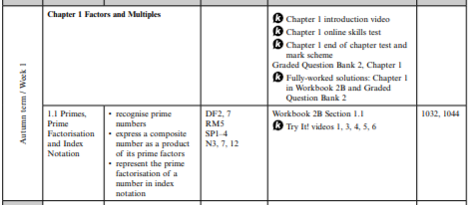

MON A 16 SEPT
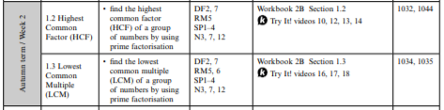
MON B 23 SEPT
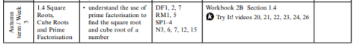
MON A 30 SEPT
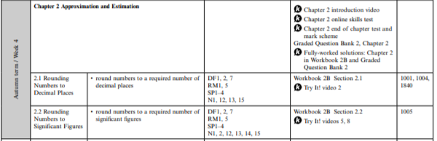

MON B 7 OCT
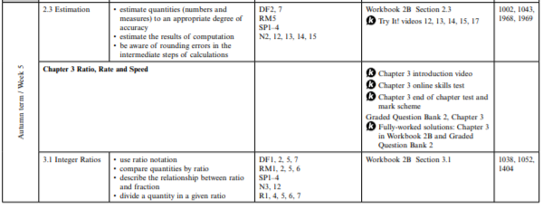
MON A 14 OCT
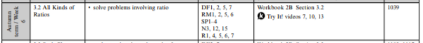

HALF TERM SAT 19 OCT – SUN 27 OCT
MON B 28 OCT
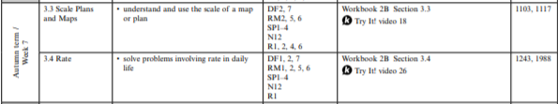

MON A 4 NOV
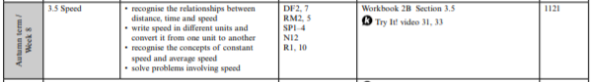

MON B 11 NOV
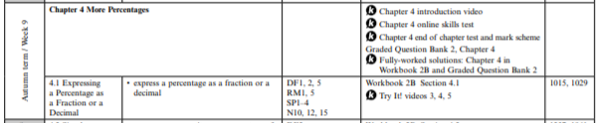

MON A 18 NOV
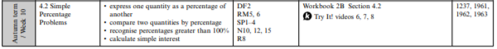
MON B 25 NOV
MON A 2 DEC
MON B 9 DEC ASSESSMENT AND GO THROUGH THE TESTS/ START STEM ACTIVITY
ASSESSMENT 1: EXTENSION SETS 1 AND 2
MAIN SETS 3, 4 AND 5
CONSOLIDATION SET 6
MON B 16 DEC COMPLETE STEM ACTIVITY
XMAS ACTIVITIES

